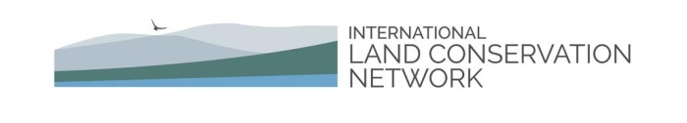

Agenda

Workshop on Emerging Innovations
in Conservation Finance

September 27, 28 and 29, 2016
Las Majadas de Pirque
Chile
Workshop on Emerging Innovations
in Conservation Finance

Las Majadas de Pirque, Chile

AGENDA: Tuesday, September 27, 2016

Field Trip to San Juan de Piche Nature Sanctuary

9:30 am Jorge Von Marees, representative of San Juan de Piche, Andrés Otero, owner and Martin Otero, owner of San Juan de Piche
Introduction to San Juan de Piche Nature Sanctuary and its management partner, Fundación Robles de Cantillana, located at the heart of Altos de Cantillana, coastal mountain range, 65 km south - west of the city of Santiago.

9:50 am Manuel Moller, CEO, Preserve in Community and Pablo Rodriguez, Operations Manager, Preserve in Community (PiC)
Introduction to the Preserve in Community (PiC) project. PiC is a platform with the ultimate goal or creating natural parks by preserving different ecosystems around the world. PIC’s objective is to create the largest community or preserves in the planet by enabling people around the world to take real action to protect our earth.

10:15 am Buses leave Las Majadas de Pirque

12:30 pm Buses arrive at San Juan de Piche Nature Sanctuary (www.roblesdecantillana.cl/)

1: 00 pm Tour of the nursery at San Juan de Piche

1:30 pm Light lunch

2:00 pm Walking tour of the property

4:00 pm Coffee and group picture

4:30 pm Depart property

7:00 pm Arrive at Las Majadas de Pirque

8:00 pm Dinner

Wednesday, September 28, 2016

8:00 am Yoga or morning hike (optional)

8:45 am Breakfast (served in the lodge)

9:30 am James Levitt, Director of the Program on Conservation Innovation at the Harvard Forest, Harvard University Manager of Land Conservation Programs, Lincoln Institute of Land Policy (Massachusetts, USA). Workshop Introductions and Objectives.

9:50 am TOPIC 1: LEVERAGING PHILANTHROPY WITH PUBLIC SECTOR COMMITMENTS

1.1 Hernán Mladinic, Executive Director, Pumalín Park, Tompkins Conservation, Puerto Varas, Chile. Creating National Parks and Generating Prosperity along the Ruta de los Parques in Patagonia. Focus: Douglas and Kristine Tompkins have invested more than US$250 million to establish vast reserves in Chile and Argentina. Tompkins Conservation is now offering more than one million acres of that land to the Chilean Government as National Parks, and is asking the Chilean Government to also designate more than nine million acres of complementary and contiguous land as National Parks, creating a system that will stretch from Puerto Montt in the north to Tierra del Fuego in the South. The system runs along Chile’s Carreterra Austral, creating a Ruta de los Parques (Route of the Parks) that should be a major ecotourism asset to the people of Chile.

1.2 Rodrigo Medeiros, Vice President, Conservation International, Rio de Janeiro, Brazil. A multi-sector initiative to protect Rio’s water supply. Focus: Conservation International is coordinating a pilot project to restore and reforest a portion of the Guandu watershed that is the channel for the majority of Rio’s domestic water supply. The pilot project is funded from a variety of sources, including a share of municipal tax revenues, and a share of the receipts from concerts sponsored by “Rock in Rio.” The objective of the project is that it be proven effective in enhancing the quality and quantity of Rio’s water supply, and that the model be proven to be an effective template for similar efforts in other Latin American countries.

1.3 Patrick Coady, Investment Banker and Former United States Representative to the World Bank, Arlington, Virginia. Response and Question Moderation

11:15 am Coffee break

11:30 am TOPIC 2: INVESTING IN GREEN INFRASTRUCTURE TO REDUCE RISK AND ADDRESS WATER QUALITY/QUANTITY CONSTRAINTS

2.1 Kathy Baughman McLeod, Director of Climate Risk and Resilience, The Nature Conservancy (TNC), Arlington, Virginia, USA. Leveraging Reinsurance Markets to Finance Conservation Investment. Focus: TNC is working with large international reinsurance companies to match them with insured clients that, in exchange for reduced premiums, are willing to invest in conservation projects that can serve to ameliorate ecosystem and financial risk (for example, coral reefs and mangrove swamps that will reduce the ecosystem and financial risks associated with hurricanes and other severe storms).

2.2 Jeffrey Allenby, Director of Conservation Technology, Chesapeake Conservancy, Annapolis, Maryland, USA. Precision conservation designed to enable nutrient trading and mitigation programs in the Chesapeake Watershed. Focus: The Chesapeake Conservancy is developing a novel Geographic Information System (GIS) application to create land cover data and topographic detail across large landscapes at a one-square member resolution. Enabled by this technology, they are working to facilitate the creation of nutrient trading and mitigation opportunities that can finance such nutrient reductions on a large scale basis.

2.3 Terry Vogt, Terra Global Capital, SF, CA, USA, Response and Question Moderation

1:00 pm Lunch

2:00 pm CONCURRENT SESSIONS: TOPICS 3 AND 4: ADAPTING DEBT FINANCE TOOLS FOR CONSERVATION ACROSS THE AMERICAS

TOPIC 3: GREEN BONDS and SIMILAR FINANCING INSTRUMENTS

3.1 Carolyn duPont. 2016 Graduate of the Joint MBA/MPA Degree Program at the MIT Sloan School and the Harvard Kennedy School. Green Bonds and Land Conservation: The Evolution of a New Financing Tool. Focus: Green Bonds emerged as a new form of environmental financing in 2007. While most investors still view them as a niche product in the overall fixed income market, green bonds have grown rapidly to nearly $37 billion in issuance in 2014, with issuers ranging from the World Bank to the State of Massachusetts. This presentation examines the current and potential future use of green bonds for financing sustainable land use and conservation projects around the world.

3.2 Leslie Durschinger, Founder and Managing Director, Terra Global Capital, San Francisco, California, USA. Financing Options for REDD+: Catalyzing a Move from Concessional to Commercial Approaches. Focus: To date, much of the funding for REDD+ has come from donor sources. To support larger scale operation, project proponents will need to attract significant private sector investment capital. Working with CONAF (National Forest Corporation) in Chile, Terra Global, is developing a financing strategy that identifies the spectrum of financing instruments and potential funders needed to secure the long-term financial viability of Chile’s ENCCRV (REDD+) program.
3.3 Lourdes Germán, Lincoln Institute, Cambridge, MA, USA. Response & Question Moderation

TOPIC 4: COMPENSATORY MITIGATION

4.2 Victoria Alonso, Templado, Santiago, Chile and Henry Tepper, Conservation Consultant, Lincoln, Massachusetts, USA. Emerging Mitigation Practices in Chile. Focus: The presenters are working together as members of a small team that is working with industrial companies in Chile to establish significant and measurably effective mitigation practices involving land conservation and sustainable stewardship. These practices are being designed to have an enduring impact over the course of many decades.

4.2 Efraím Acosta Lugo, Technical Coordinator, ProNatura Mérida, Yucatán, Mexico. Reforestation and aquifer recharging through a public-private partnership. Focus: Pronatura, in partnership with the Coca-Cola Foundation of Mexico and three agencies of the Mexican federal government (SEMARNAT, Secretariat for the Environment and Natural Resources; CONAFOR, National Forestry Commission of Mexico; and CONANP, National Commission on Protected Natural Areas), has conducted the National Program for Reforestation and Water Harvesting. Started in 2007, the program has, as of 2014 reforested some 58 million hectares, planted 61 million trees, and benefitted more than 774 communities. This presentation will explain how the program was funded, where it goes from here, and the likelihood that it can be replicated in other countries.

4.3 Roberto Peralta, Peralta, Gutiérrez y Asociados Limitada Abogados. Response and Question Moderation.

3:30 pm Coffee break

4:00 pm TOPIC 5: EMERGING POLICY & FINANCE FOR LAND CONSERVATION IN THE AMERICAS

5.1 Rand Wentworth, President Emeritus, Land Trust Alliance (USA) and Resident Fellow, Harvard Kennedy School Center for Public Leadership, Cambridge, Massachusetts, USA. Success, at Long Last: Enhanced Conservation Tax Provisions in the United States. Focus: The strategy and implementation of a multi-year, ultimately successful campaign in the United States to establish enhanced tax credits for conservation easements.

5.1 Pancho Solis, Consulting Conservationist, Santiago, Chile. A Work in Progress: the Chilean Derecho Real de Conservation. Focus: the multi-year campaign to pass legislation regarding the Derecho Real de Conservation, an inventive legal structure enabling land protection in Chile analogous to conservation easement is the United States and Canada.

5.3 Laura Johnson, Director of the International Land Conservation Network and Chairperson, Land Trust Alliance, Concord and Cambridge, Massachusetts, USA. Response and Question Moderation.

5:15 pm Afternoon Wrap-Up session

5:30 pm Afternoon Adjournment

7:30 pm: Evening Reception

8:00 pm: Dinner and Musical Interlude

9:00 pm: Keynote Panel: Land Conservation - the Road Travelled, and the Road Ahead for Chile

- Rafael Asenjo, Chairman, Environmental Tribunal, Santiago, Chile
- Jorge Burgos, Former Minister of the Interior, Government of Chile
- Alfonso De Urresti, Senator (Valdivia), Chair of Constitutional Committee, Chile
- Alejandro Quintana, Grasty Quintana Majlis & Cia, Abogados, Santiago, Chile
- James Levitt, moderator

Thursday, September 29, 2016

8:00 am Yoga or morning hike (optional)

9:00 am Breakfast in the dining room

9:30 am CONCURRENT: TOPICS 6 AND 7: Private and Civic Sector Conservation Initiatives

TOPIC 6: VALUE CAPTURE

6.1 Enrique Silva, Lincoln Institute of Land Policy, Cambridge, Massachusetts, USA. An Overview of Value Capture. Focus: Privately funded improvements by land-owners can increase the value of their land and property. Public actions, such as investments in infrastructure, the provision of public services, and planning and land use regulation, can also affect the value of land and property. Value capture is a means to realize as public revenue some portion of that increase in value through various revenue-raising instruments. Silva, who supervises research that ranges from land-based fiscal instruments, the fiscal and land policy dimensions of large scale urban projects, affordable housing and urban segregation, to planning regimes and climate change adaptation, has helped policy makers across North and South America better understand and effectively use this tool.

6.2 Maria Cristina Rojas Eberhard, Urban planner advisor, Columbia. The Municipality of Bogotá, Colombia has been considering using land value capture mechanisms to purchase the van der Hammen urban forest reserve and secure it as a key component of a larger planned green belt or buffer zone for Colombia’s capital city. The case highlights the challenges both the private and public sector face in securing large conservation areas in the context of rapid urbanization and high demand for land to accommodate housing. Currently, the Municipality of Bogotá is considering re-zoning the land in and around the reserve to allow development, a move which has also mobilized academic and civic interests to consider other ways to maintain and finance the reserve as part of the city’s green cordon.

6.3 Amy Cotter, Lincoln Institute of Land Policy, Cambridge, Massachusetts, USA. Response and Question Moderation.

TOPIC 7: THE POWER OF CONSERVATION FINANCE NETWORKS

This will be an interactive panel discussion featuring:

- Leigh Whelpton, Executive Director, Conservation Finance Network, Arlington, Virginia, USA.
- Sylvie Goyet, Conservation Finance Alliance, Noumea, New Caledonia
- Peter Stein, Managing Director, Lyme Timber Company and founder of the Conservation Finance Boot Camps, Hanover, New Hampshire, USA.

11:00 am Coffee Break
11:15 am TOPIC 8: WHERE DO WE GO AFTER PARIS?

This panel will consider how the climate change and land protection communities have an imperative to work together to catalyze public and private investment in the 21st century (e.g., in carbon markets, renewable energy markets, sea-level rise adaptation/stormwater control markets and desalination markets, yielding hundreds of billions or trillions per year of green and gray infrastructure investments)

Panelists

--- Ken Berlin, President and CEO, The Climate Reality Project, Washington, DC, USA
--- Tomás Folch, Research Associate, Harvard Graduate School of Design, Santiago, Chile
--- David Boghossian, Managing Director, Commonwealth Impact Partners, Cambridge, MA
--- Jared Chase, former Chair, State Street Global Alliance, State Street Bank, Boston, MA

Moderator
--- James Levitt, Harvard Forest, Harvard University & the Lincoln Institute of Land Policy

Breakout Groups: Convened by Tomas Folch, Ken Berlin, Jim Levitt

1:00 pm Lunch

2:00 pm Plenary Discussion – Next Steps and Internetworking. Focus: How can we use the networks that are now emerging, as well as the emergence of trillion dollar markets to catalyze the growth of conservation finance?

3:00 pm Adjournment

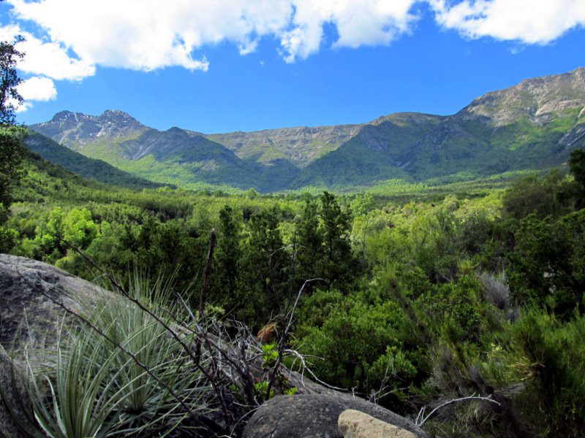
Credits: Cover page photo by Ken Wells, Tunk Lake, Sullivan, Maine, USA;
page 7 photo courtesy of Robles de Cantillana at www.roblesdecantillana.cl.

